Testing

Once we had completed building the website we undertook a number of different methods to test it.

Firstly we made sure to click all the links on every page to make sure they all navigated to the correct page, we tried entering different inputs in the form to make sure any relevant error messages were successfully shown and used the website on desktop monitors, laptops, iPads and mobile devices to make sure the site looked okay on different screen sizes.

Tablet Screenshots

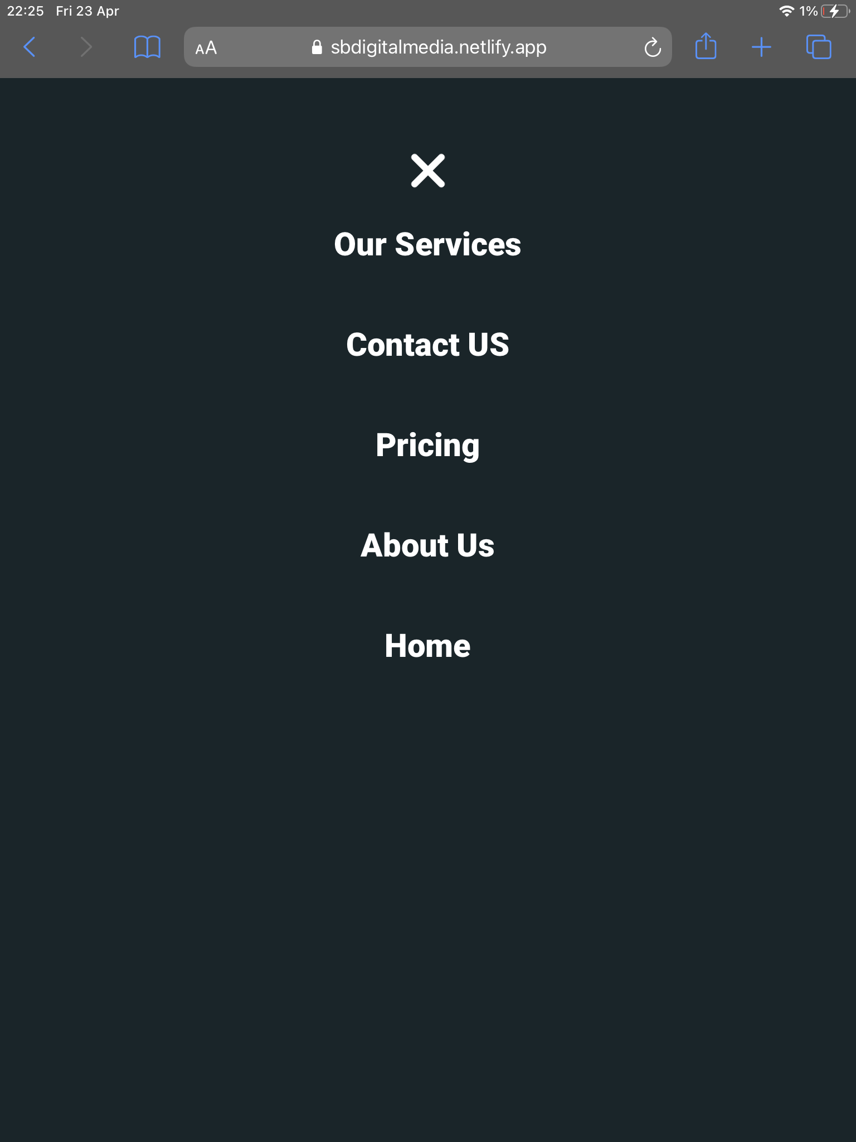

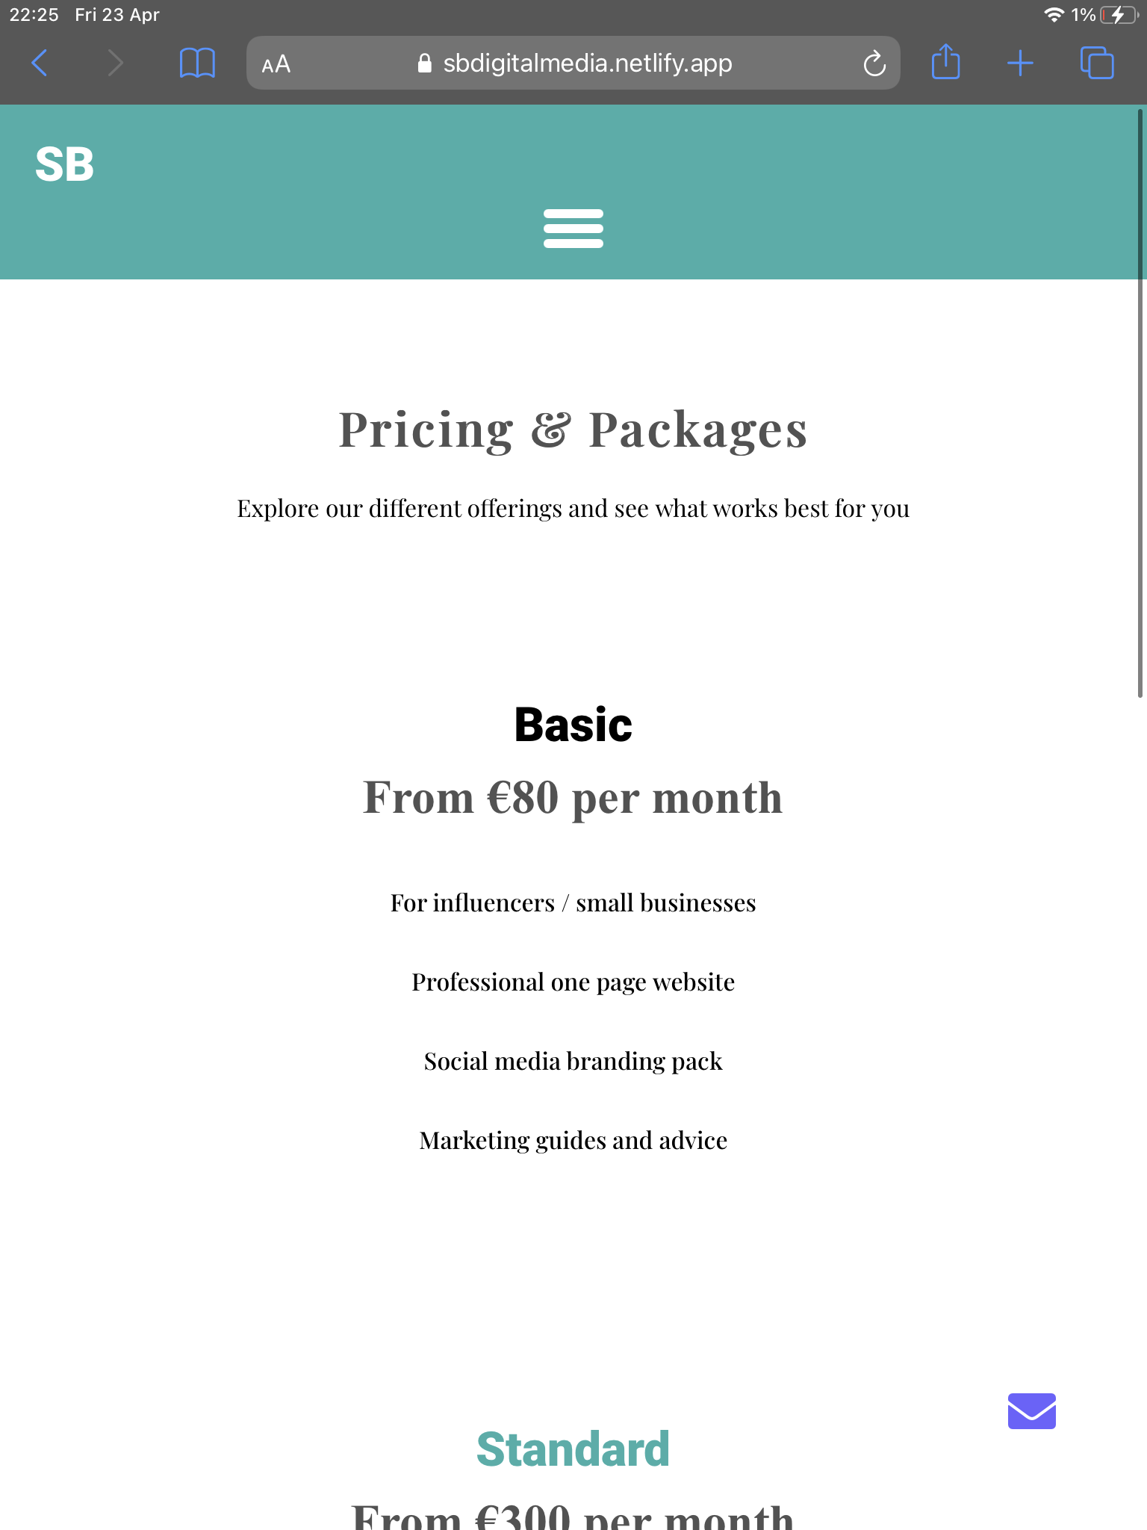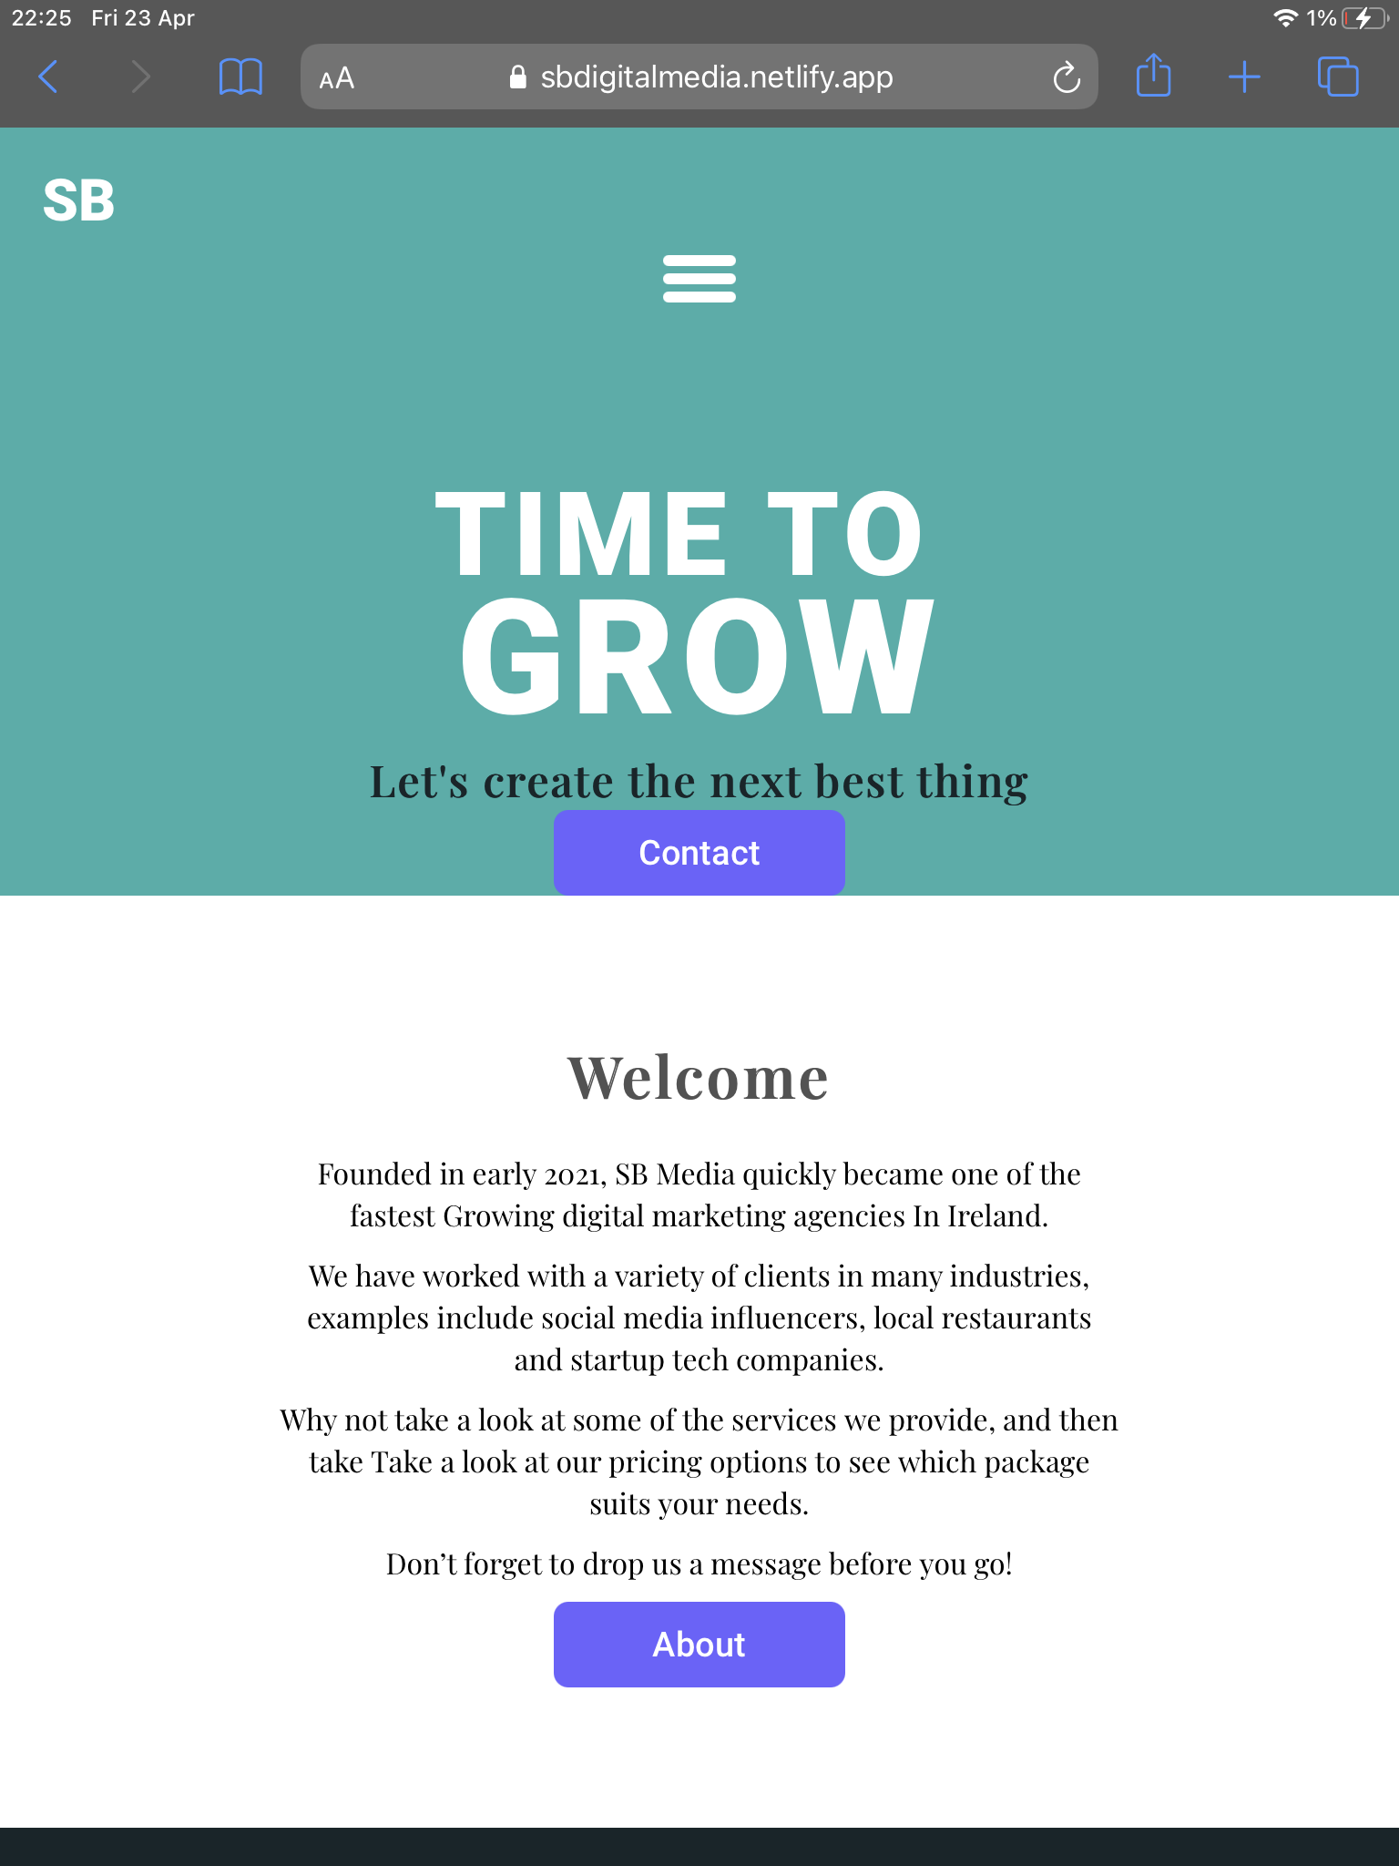

Mobile Screenshots

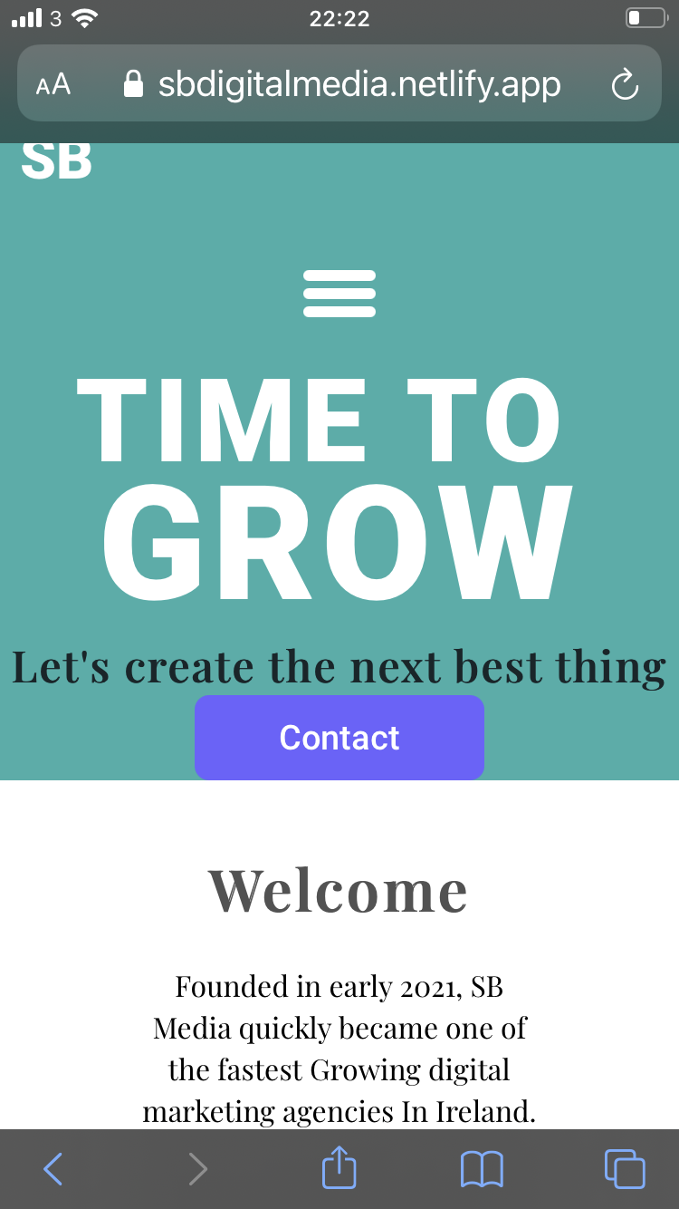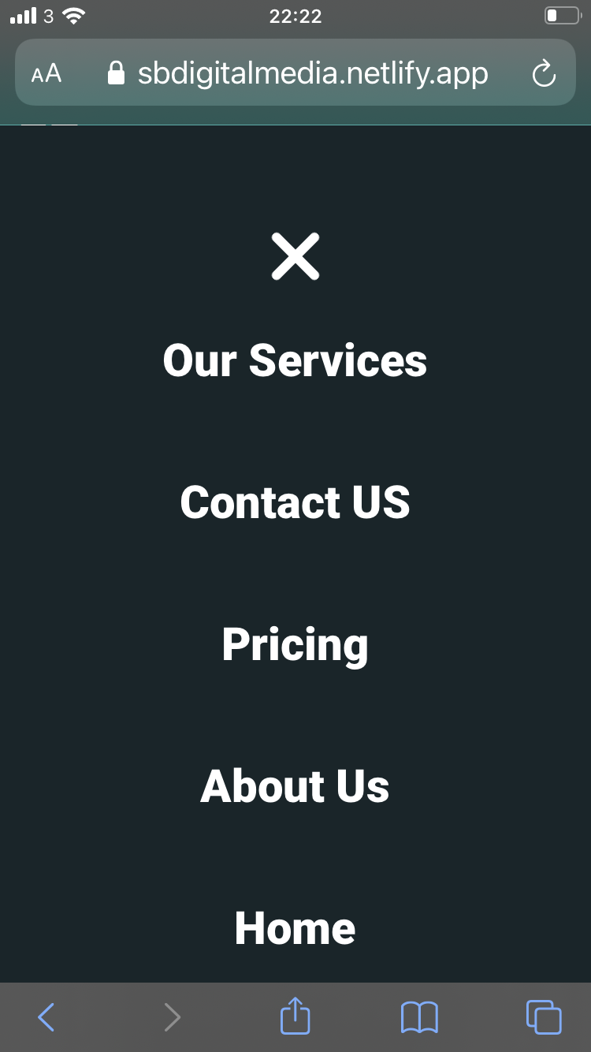

Form validation manual testing on mobile

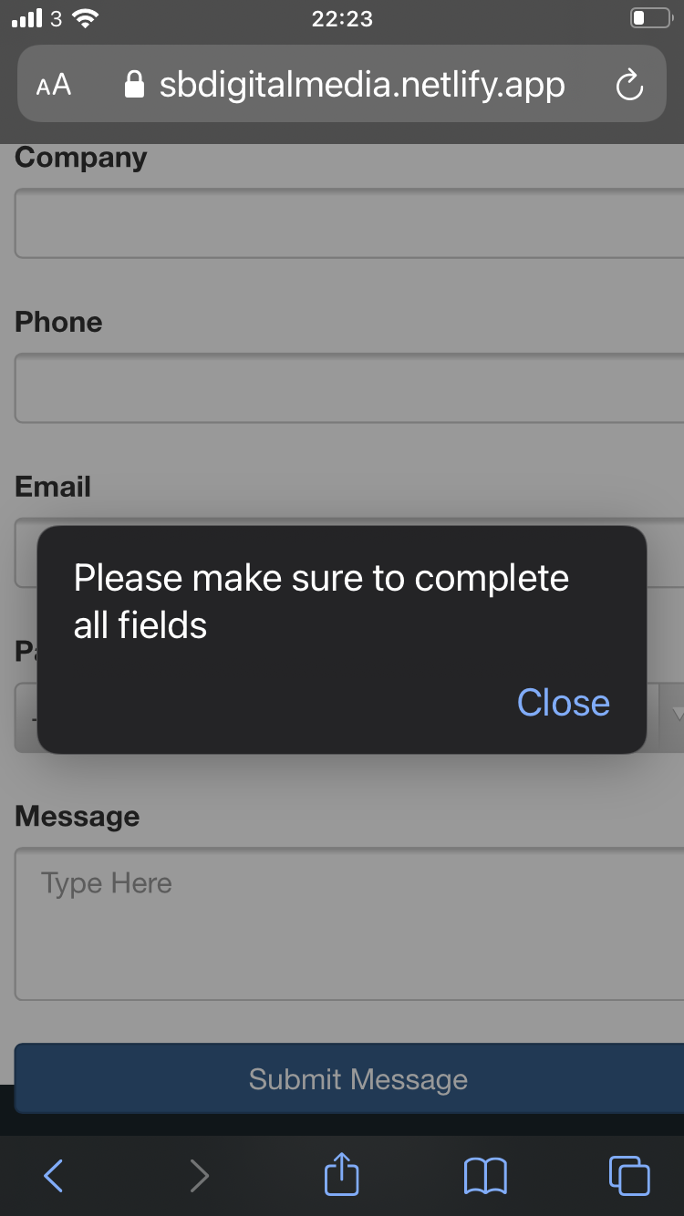

Once this site was hosted I was also able to ask some friends and family to go through the website and see if they could find anything not working/ any issues that needed to be fixed.

W3 Validation service

Using the W3 validation service we were able to make sure out HTML syntax contained no errors and that we were following best HTML practices. One example of an error the service highlighted for us was that initially we had our buttons wrapped in link tags to navigate around the website. The service let us know that they shouldn’t be used this way, so instead we just styled our a tags to look like buttons and just removed the button tags completely.

The service was also useful in highlighting any syntax errors/stray opening or closing tags that may have been hidden in the code.

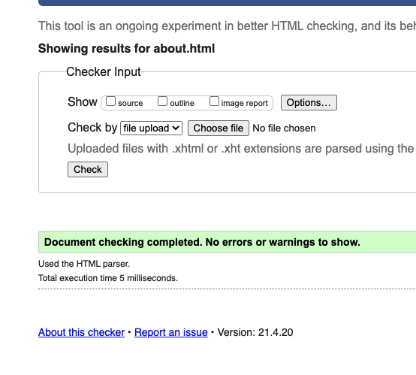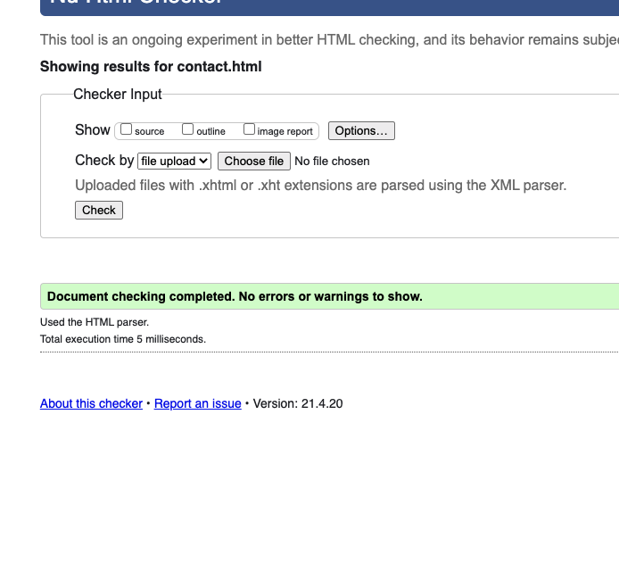

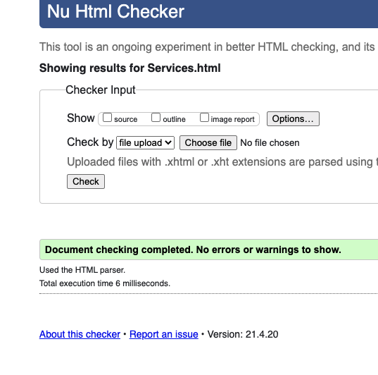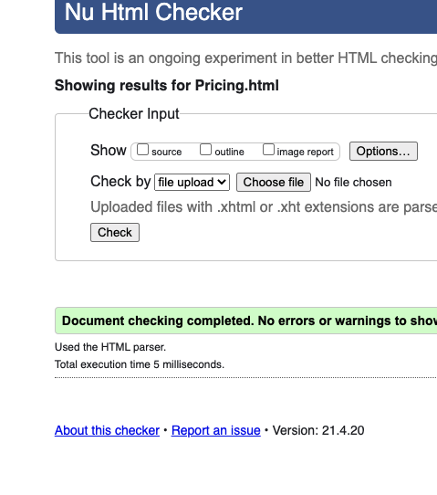

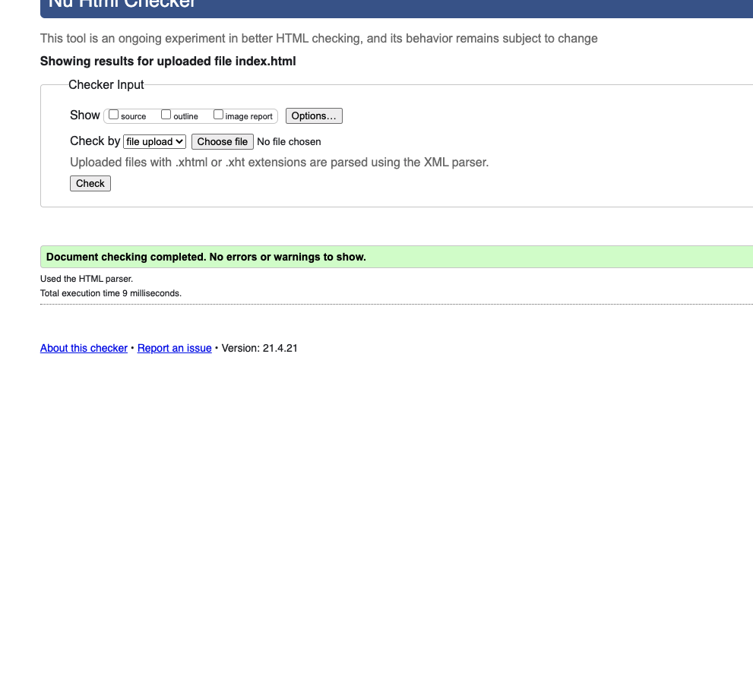

The validation service is a quick and easy way of finding and fixing any syntax errors or bad HTML practises. We can see from the images above that we have resolved issues we had with our code.

https://validator.w3.org/

Another testing method was to make sure our links were valid, this was done through the W3 link validation service.

https://validator.w3.org/checklink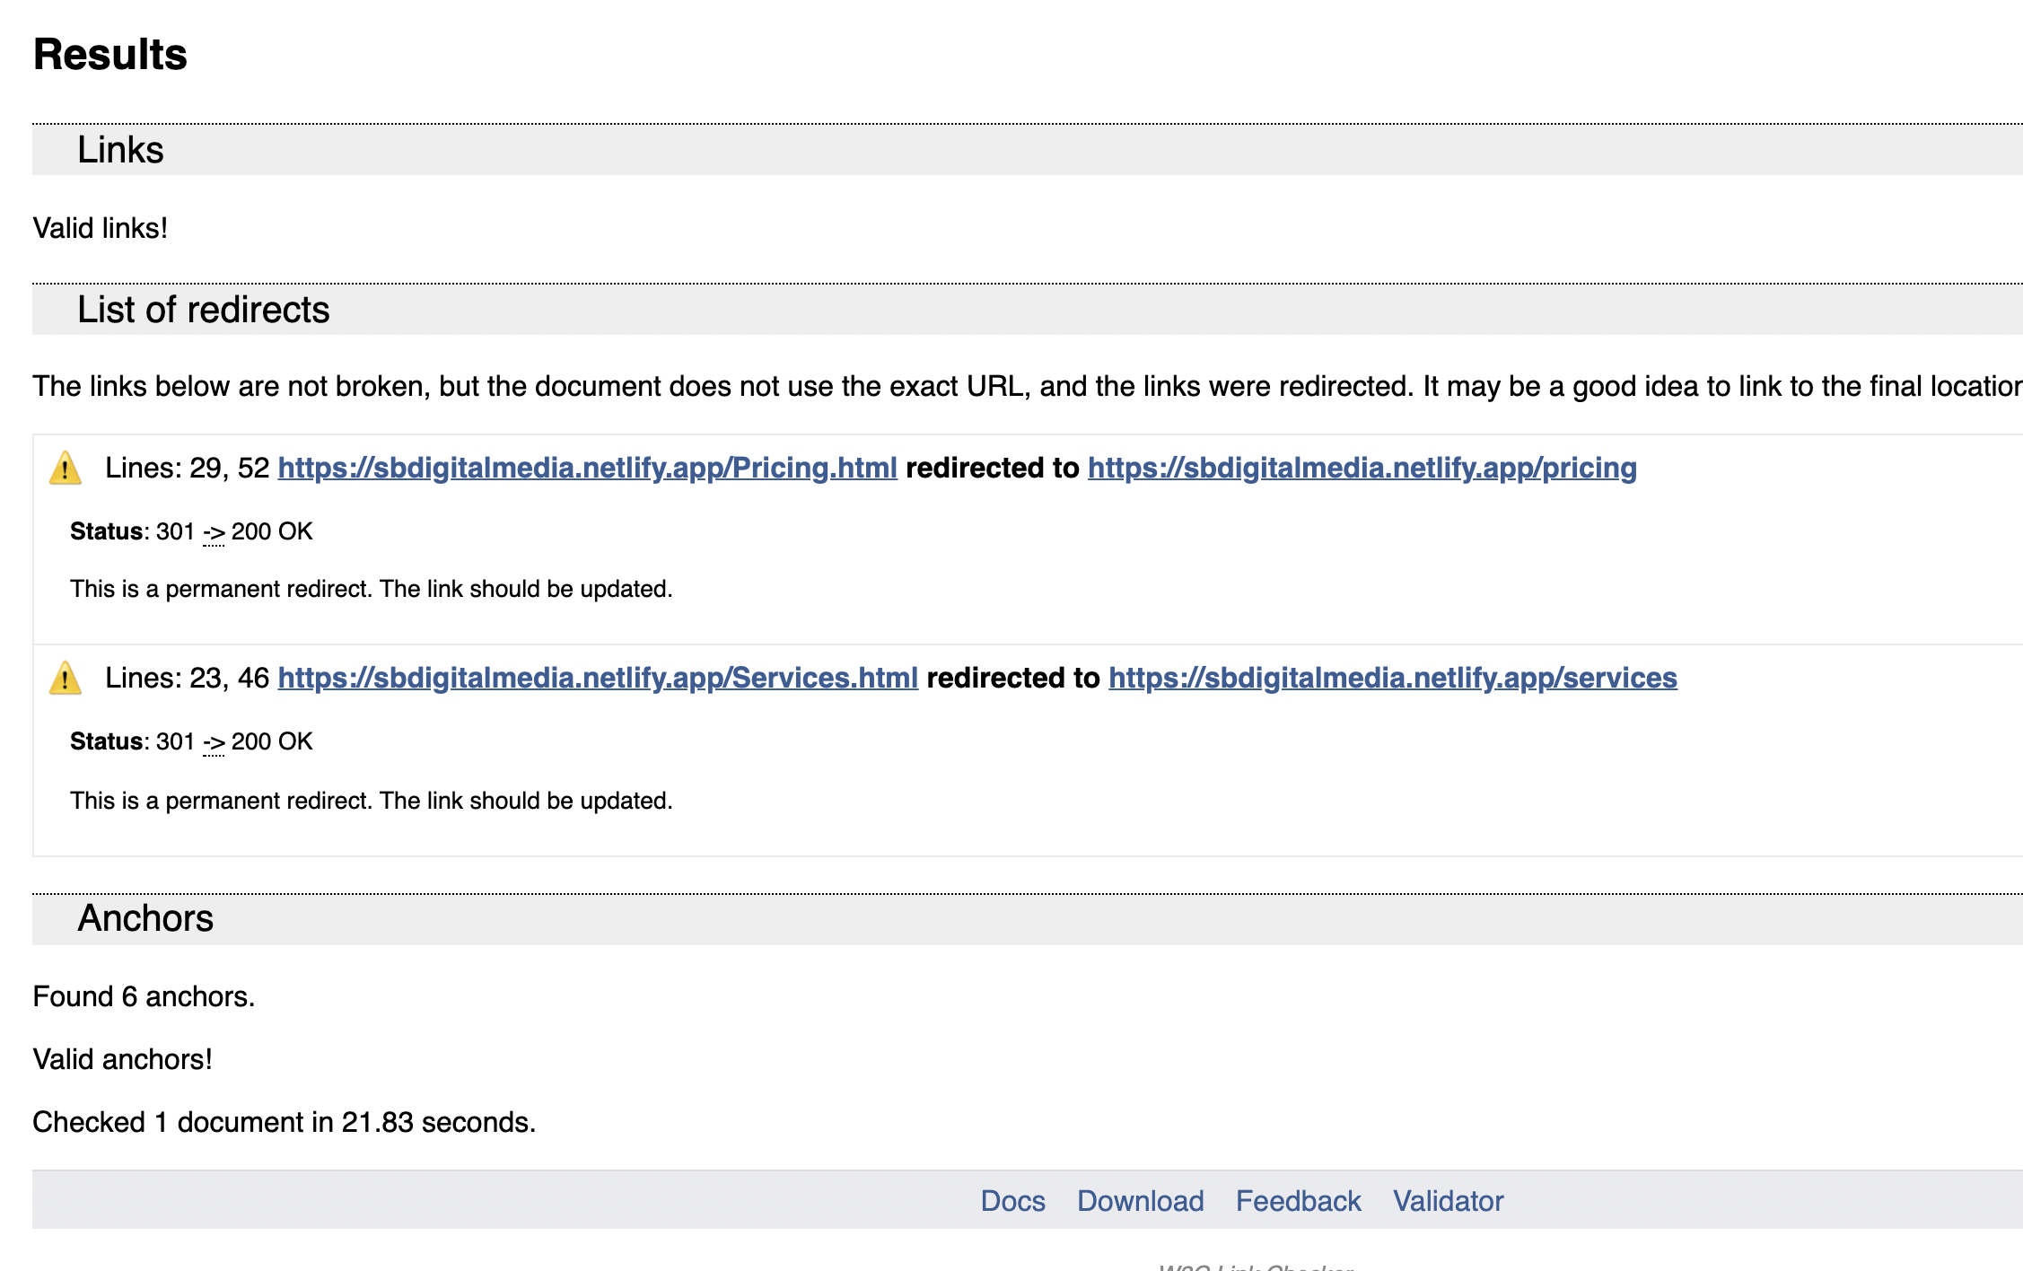

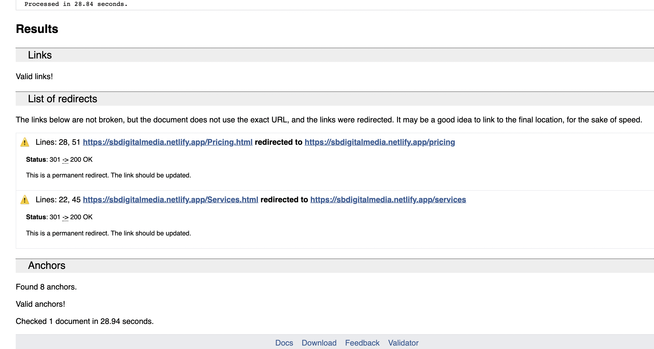

Lighthouse

Then using the Lighthouse tool in the Chrome developer tools, we were able to test aspects of the site such as performance, accessibility, best practices and SEO. We were given some great tips from this tool on how we could improve the site, such as moving our script tags from the head to the end of the body, placing an aria-text attribute into links that didn’t contain text for people using screen readers and in using certain meta tags and titles to improve SEO performance.

https://developers.google.com/web/tools/lighthouse

As can be seen in the below screenshots, we were able to achieve scores between 90-100 throughout the site.

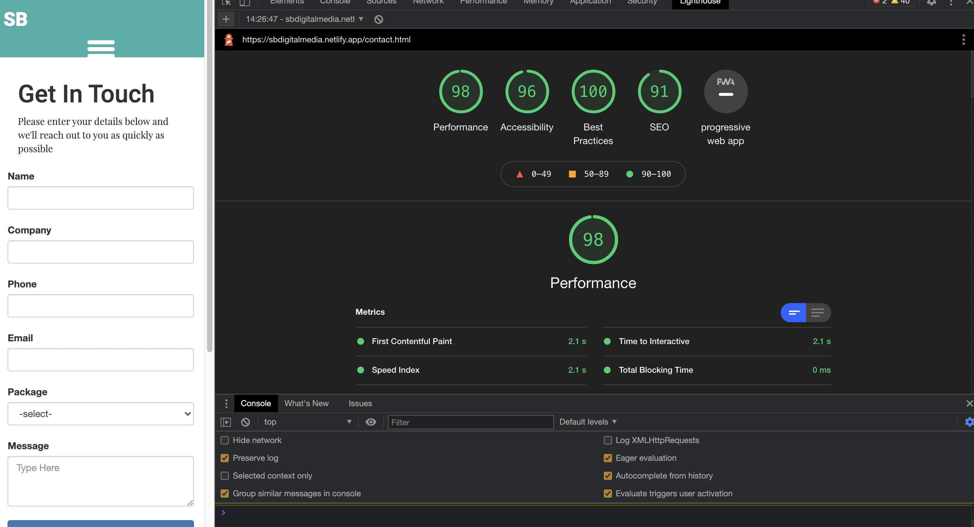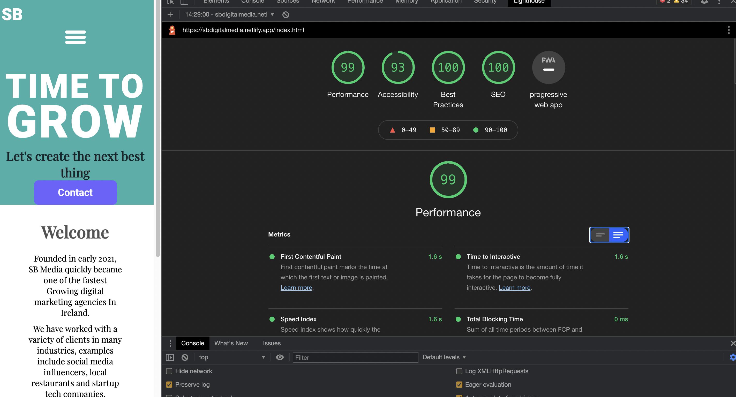

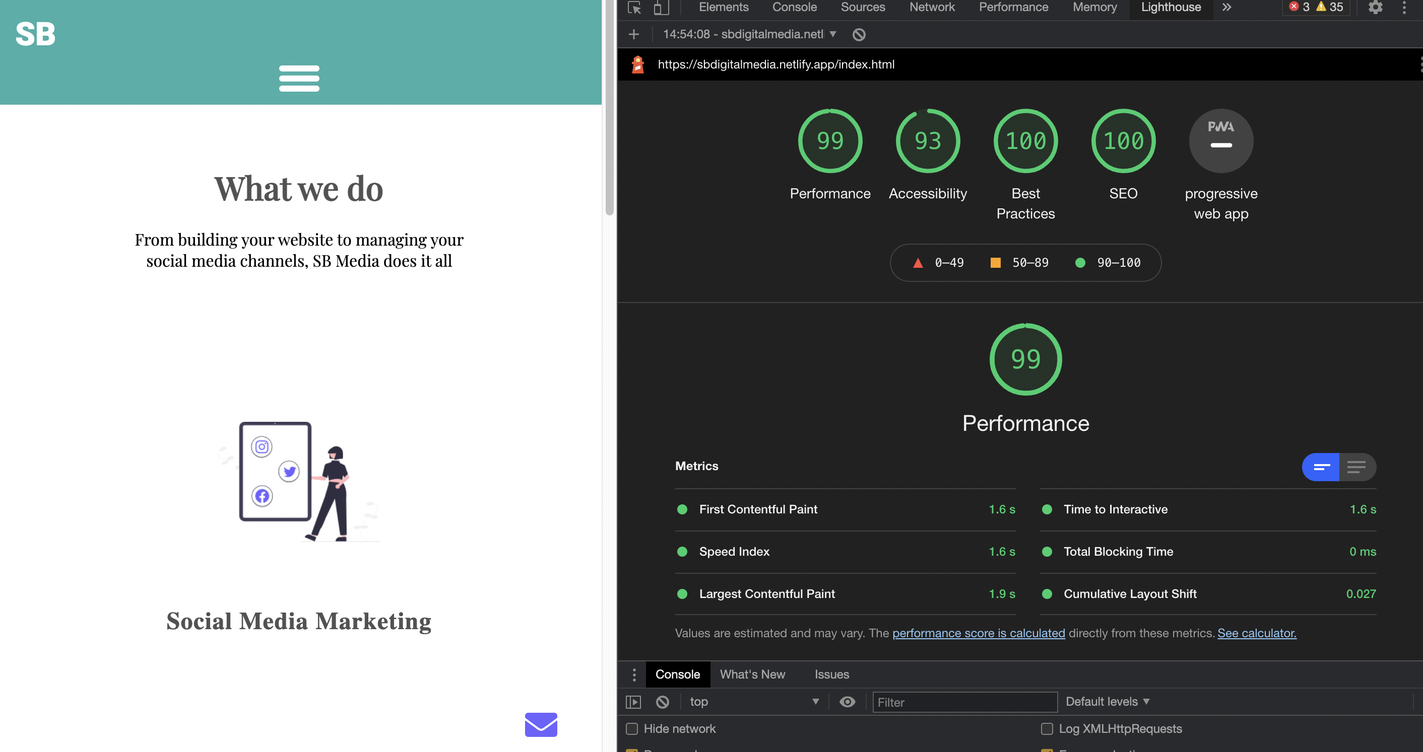

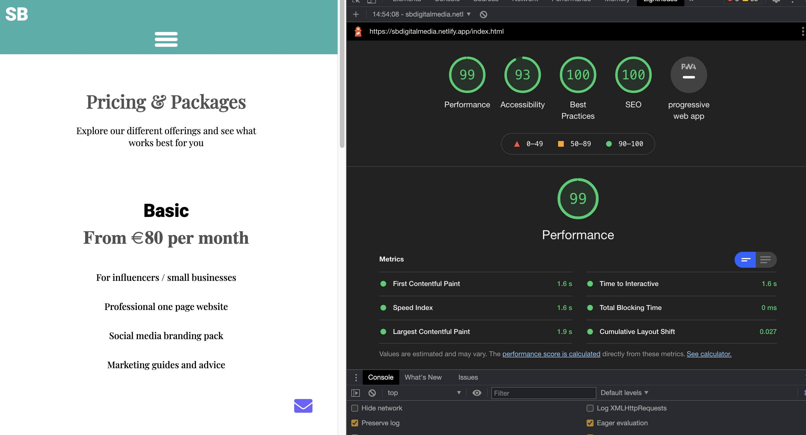

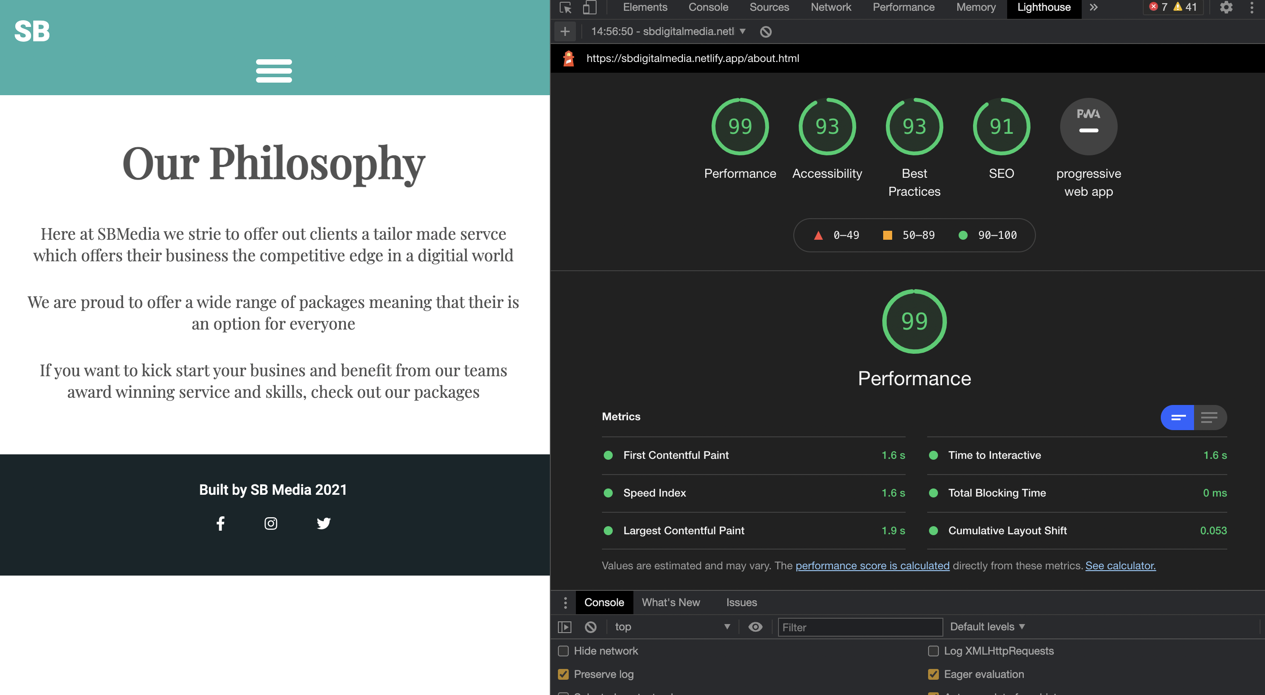

We took a couple of different steps to optimise the website.

1. Ensured images were set to “display:none” for small screens (tablets/mobile devices) This is to make the page easier to navigate on mobile but also taking into account that some users may be using a limited amount of mobile data and that loading images is an unnecessary drain on this.

2. As mentioned in the Testing section we moved our script tags to the end of the body to let the HTML elements load before waiting on js file, JQuery links and font awesome icon links. This ensures that the site loads much quicker for users.

3. Used the Google mobile friendly test to test if the site was easy to use on mobile devices.

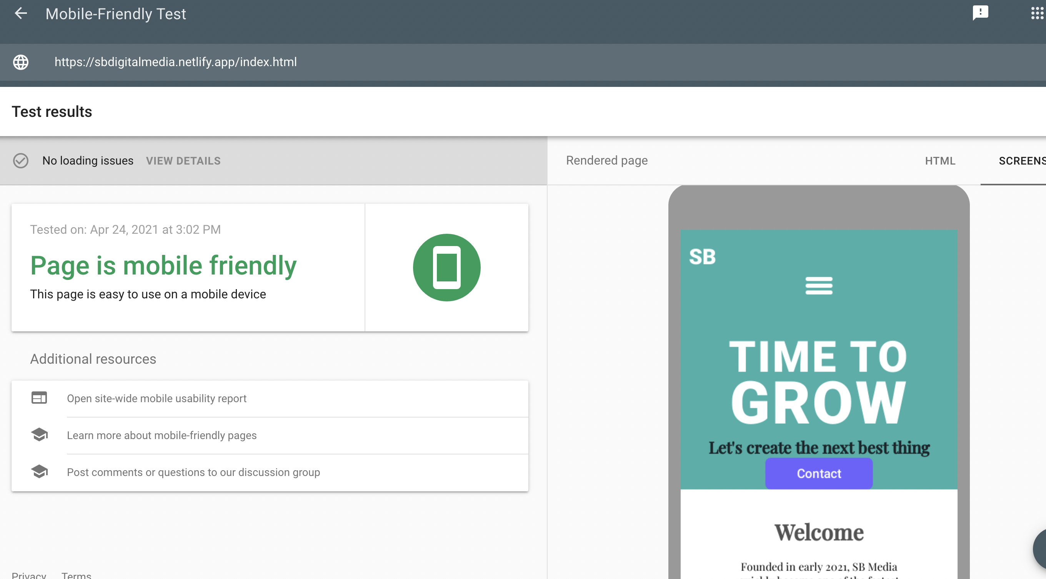

SEO

As stated in the testing section we managed to get good SEO scores for our site based on the Lighthouse tool tests. We did this by looking up articles online and following their advice. Some of the steps we took were to:

1. Give our pages appropriate title tags, and try to imagine what would attract a user to the site if they saw the title in the search results eg for our index we have:

<title>Best Digital & social media marketing agency in Dublin, Ireland</title>

2. Give the pages appropriate descriptions that are clear, straightforward and would attract potential clients.

<meta name="description" content="SB media is a top Digital marketing Services agency located in Dublin. We can grow your business through professional website design, branding, SEO and social media marketing!”>

3. Try to include keywords such as marketing, SEO, website design, social media as much as we could in our meta tags and throughout the site in our content paragraphs.

4. Used alt tags in our images that relate to the services the company would offer eg social media, branding etc.

5 Use a favicon image to display the logo fo our site in the browser tab.

6. Added in the word digital into our main heading <h1> and made sure to only use 1 h1 to structure the page better.

Hosting

To host the site we used the netlify service. A remote GitHub repository was created and the site uploaded to Github. Netlify easily allows us to host our site through Github.

<https://www.netlify.com/>

<https://sbdigitalmedia.netlify.app/>

Design patterns Used

Hamburger menu (mobile dropdown)

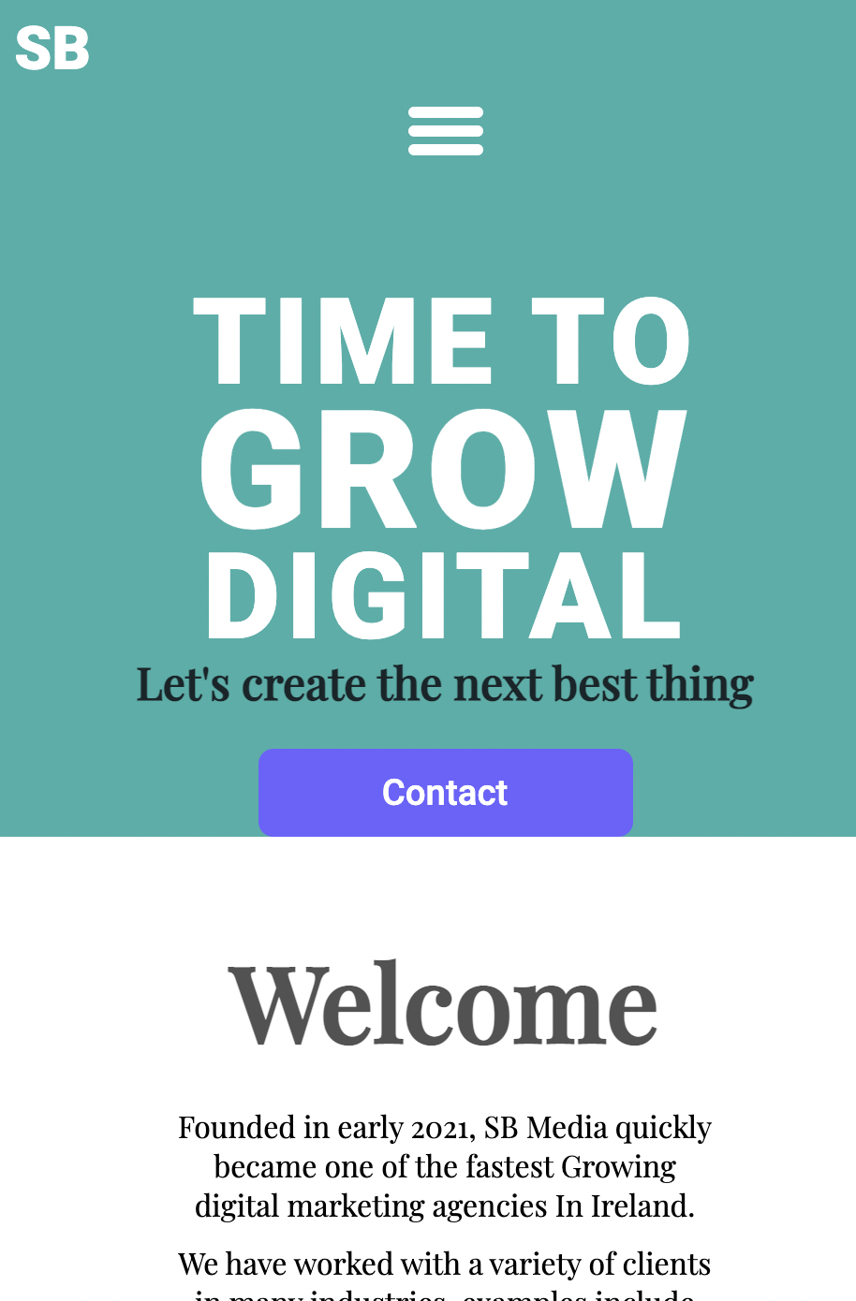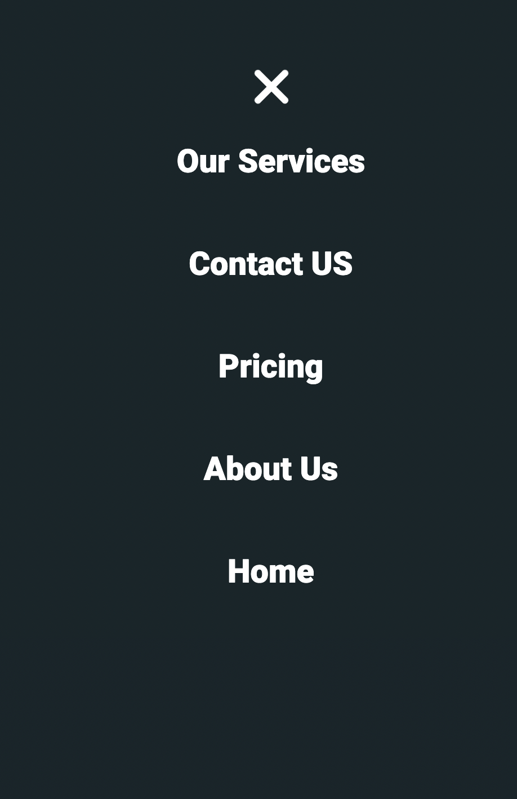

Pricing Table design pattern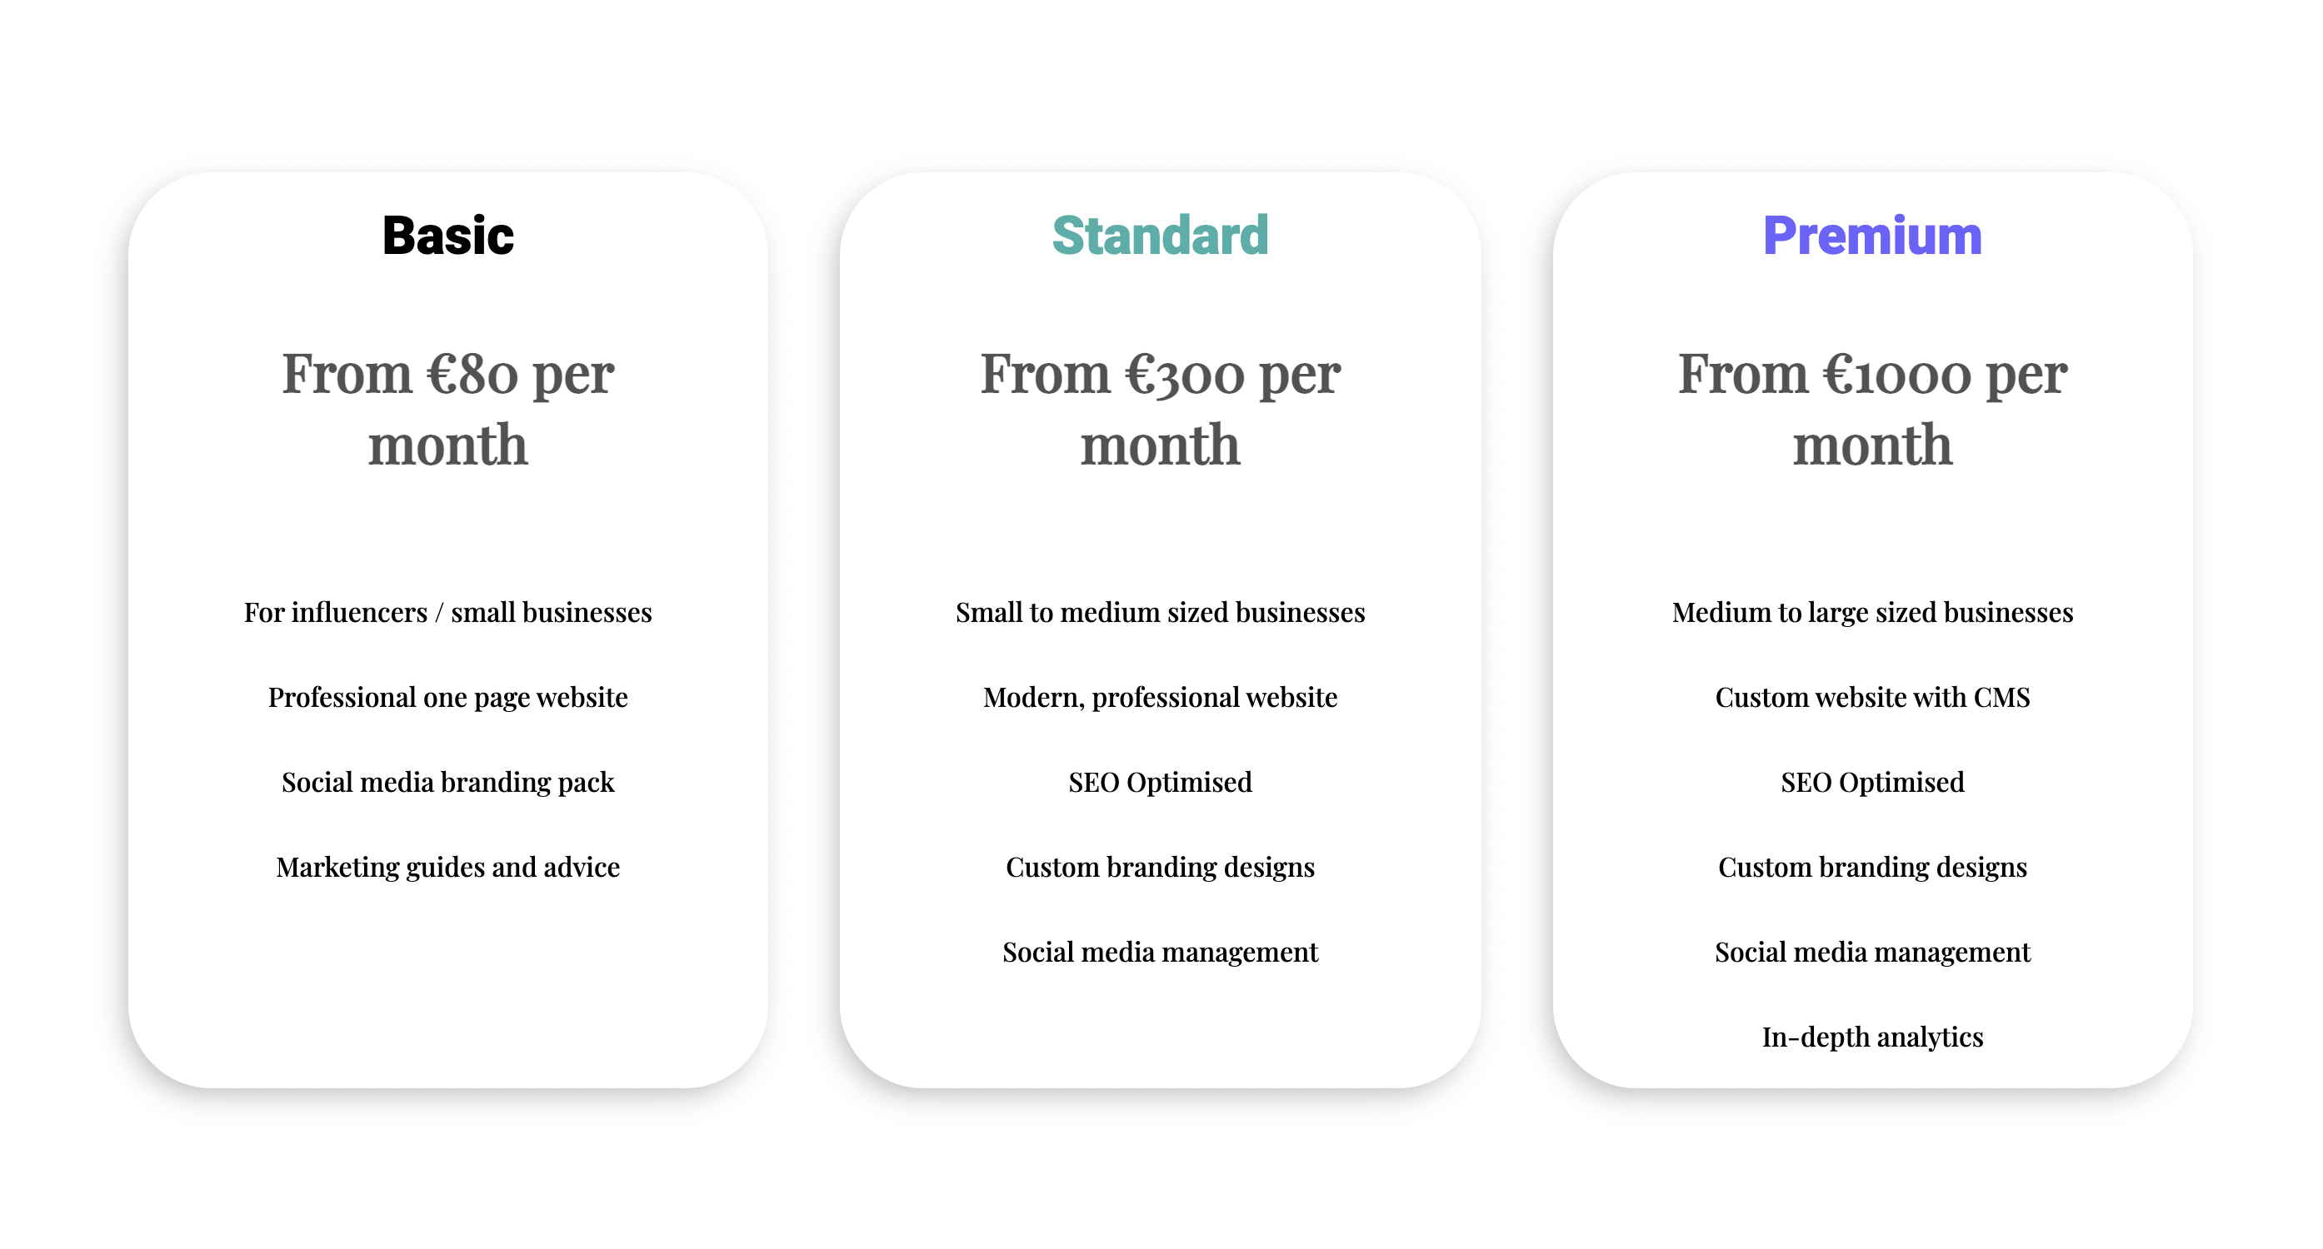

Select dropdown for different options

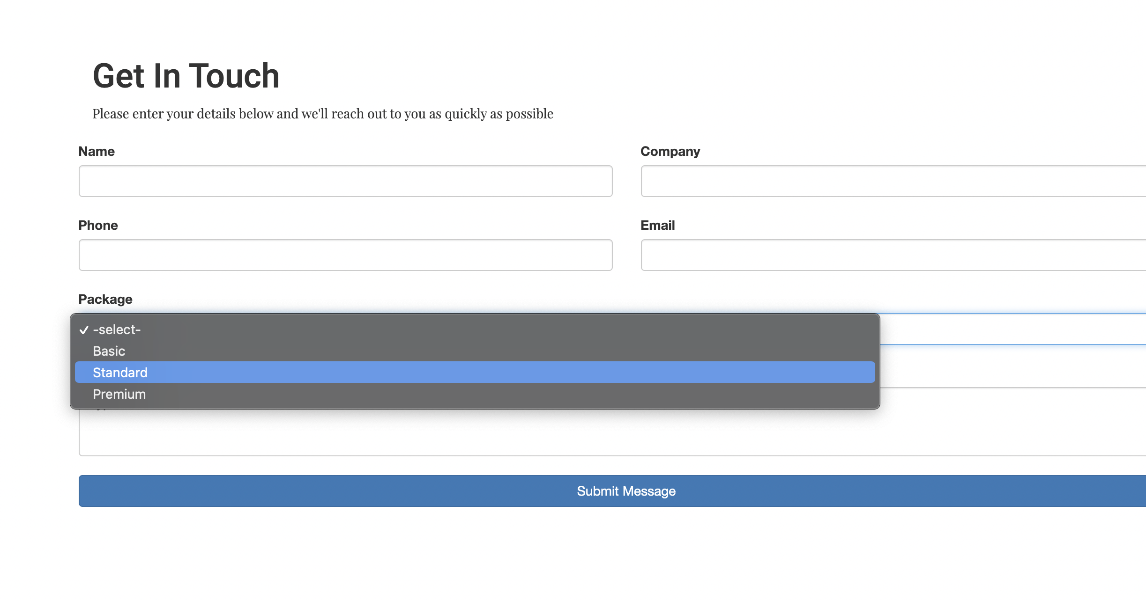

Grid pattern

